**Andy Clay**

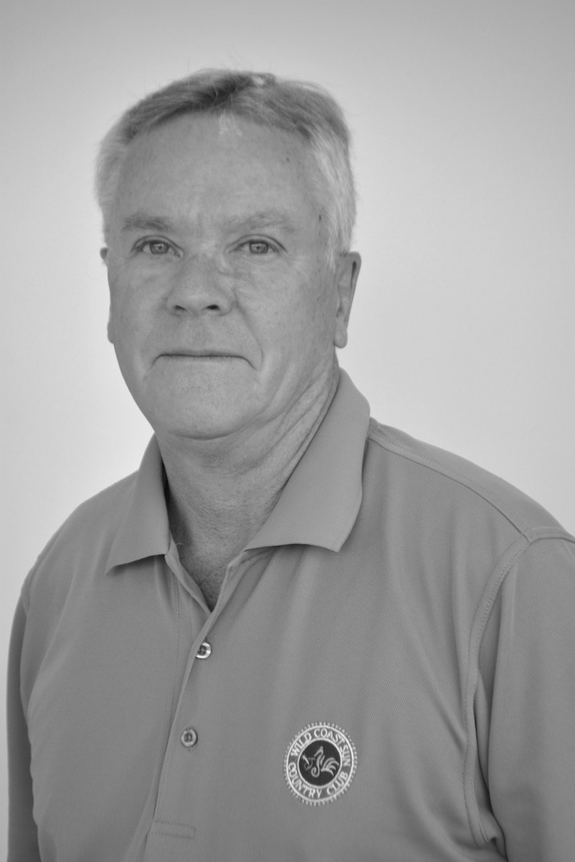

Principal Consultant | Minvest | Transaction Advisory Services

Tel: +27 11 772 3000

Mobile: +27 83 309 4232

Email: Andy.Clay@za.ey.com

**Background**

* Andy is a principal consultant in the Minvest team within Transaction Advisory Services, based out of the Johannesburg Office.
* Andy studied at the University of Cardiff where he obtained an Honours degree in geology. He continued his studies at the University of Witwatersrand completing a Masters in Economic Geology. He obtained a Graduate Degree of Engineering at the University of Witwatersrand before completing a Masters in Mining Engineering. He also has a Diploma in Business Management from Damelin and a Diploma in Tax Management and Planning from the University of the Witwatersrand.

Skills

Andy has more than 30 years experience in the minerals industry, from field geology, research, and mineral resource management to commercial due diligence and evaluation of a wide range of local and international mineral assets. In additionhe has more than 30 years of experience working with commercial banks and financial institutions on transactions in the minerals industry, and has been involved in the preparation of numerous reporting codes and rules for compliance and reporting in the public domain.

Andy’s key areas of expertise lie in the detailed financial valuation of mineral and mining projects using discounted cash flow models and comparative valuation techniques. In this regard he has undertaken numerous valuations for most mineral and oil and gas commodities over the last thirty years. These valuations have been used in listing and merger documentation both in local and international stock exchanges and for the private use of the companies concerned.

Andy continues to seek innovative solutions to many mineral asset problems. This includes making water a defined mineral resource and reassessment of historical project data. Mr Clay currently has a special interest in incorporating oil and gas reporting procedures into the general application of mineral asset valuation.

* Professional experience - selected:
* QRE report for Energem oil and gas projects in Chad and Gabon for the TSX
* Assessment of the Renergen unconventional gas resources in the Free State
* Review of the Badimo unconventioanl gas resources in the Ladysmith area
* Review of oil and gas potential in the Ural Mountains
* Chairman of the South Africa Oil and Gas Committee (SAMOG) as the coordinator of the preparation and promulgation of the SAMOG Code
* Assisting with the JSE Listing Requirements for Oil and Gas
* Detailed assessment of oil and gas valuation methodologies
* Assessment of Technical and Commercial Information for J Francks Portfilo in onshore Angola
* Valuation for Forrest Oil
* Assessment of valuation transaction for CNG gas assets
* Technical Report and Valuation for Smart Carbon Combrink Coal
* Independent Opinion for Optimum Coal
* Strategic Advisor for Smart Carbon and shale oil in Ethiopia
* Assessment of Lake Kivu unconventional gas project

Professional Codes and Committees

Andy has been involved in regulatory code writing for almost his entire career. He has a deep knowledge of the history behind the codes and how they have developed. These include but is not restricted to the following: -

* The JSE Listing Requirements with a specific focus on Section 12
* The Hong Kong Listing Requirements with a specific focus on Chapter 18
* The SAMREC Code as the South African version of a CRIRSCO Code
* The SAMVAL Code and valuation reporting
* The IMVAL Code as the international over arching reporting standard for mineral asset valuation
* The NI43-101 reporting standard for minerals in Canada
* The Petroleum Resources Management Systeme or PRMS for oil and gas
* The Investement Analysts Society and representing analysts in the context of discipline and registration
* The NI51-101 and the oil and gas reporting in Canada and North America
* Responses to the Industry Guide 7 for the New York Stock Exchange
* Communication with the Australian Securities Commission with repsect to recognition of the VALMIN Code
* Geoethics for the Global Geoscience forum

Special Interests

Andy has a wide network of professional contacts in most countries and in most minerals. As a leader his special interests include new areas of development in the sciences and financial valuation in all instruments. At the moment water and energy are key topics of development and radical transformation.

Andy is involved in Expert Witness work and has adopted the Australasian Expert Witness standards as a basis to fulfil his role.

Memberships

Andy has been a member of many organisations but in recent years has reduced this to the following: -

* Natural Scientists Act professional geologist (Statutory Registration in South Africa)
* Fellow of the Geological Society of South Africa
* Member of the South African Institute on Mining and Metallurgy
* Fellow of the Australasian Institue of Mining and Metallurgy
* Member of the American Association of Petroleum Geologists
* Member of the Investment Analyst Association in South Africa